2016/2017 Visitation Card
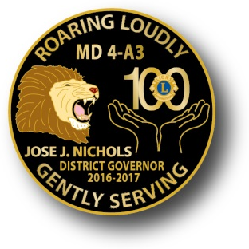

José J. Nichols, District Governor
Roving Lion
Date | Project Chair &  Project Name | Club | # Attending

Region/  Zone | Club Name | Date | Signature
L-1 | Atascadero
L-1 | Paso Robles
L-1 | San Miguel
L-1 | Santa Margarita
L-1 | Shandon Valley
L-1 | Templeton
L-2 | Arroyo Grande
L-2 | Cambria
L-2 | Cal Poly SLO
L-2 | Cayucos
L-2 | Los Osos Branch Club
L-2 | Morro Bay
L-2 | Nipomo
L-2 | Pismo Beach
L-2 | San Luis Obispo
I-3 | Allan Hancock College
I-3 | Santa Maria Noontimers
I-3 | Santa Maria Sunrisers
I-4 | Lompoc Host
I-4 | Orcutt
I-4 | Vandenberg Village
O-5 | Carpinteria
O-5 | Goleta
O-5 | Santa Barbara Host
O-5 | UC Santa Barbara
O-6 | Ojai Valley
O-6 | Ventura Downtown
N-7 | El Rio
N-7 | Oxnard Channel Islands
N-7 | Oxnard Noontimers
N-7 | Saticoy
N-8 | Camarillo Ambers Light
N-8 | Fillmore
N-8 | Pleasant Valley
N-8 | Santa Paula
N-8 | Simi Valley-Moorpark

2016/2017 Visitation Card

José J. Nichols, District Governor
Roving Lion
Date | Project Chair &  Project Name | Club | # Attending

Region/  Zone | Club Name | Date | Signature
L-1 | Atascadero
L-1 | Paso Robles
L-1 | San Miguel
L-1 | Santa Margarita
L-1 | Shandon Valley
L-1 | Templeton
L-2 | Arroyo Grande
L-2 | Cambria
L-2 | Cal Poly SLO
L-2 | Cayucos
L-2 | Los Osos Branch Club
L-2 | Morro Bay
L-2 | Nipomo
L-2 | Pismo Beach
L-2 | San Luis Obispo
I-3 | Allan Hancock College
I-3 | Santa Maria Noontimers
I-3 | Santa Maria Sunrisers
I-4 | Lompoc Host
I-4 | Orcutt
I-4 | Vandenberg Village
O-5 | Carpinteria
O-5 | Goleta
O-5 | Santa Barbara Host
O-5 | UC Santa Barbara
O-6 | Ojai Valley
O-6 | Ventura Downtown
N-7 | El Rio
N-7 | Oxnard Channel Islands
N-7 | Oxnard Noontimers
N-7 | Saticoy
N-8 | Camarillo Ambers Light
N-8 | Fillmore
N-8 | Pleasant Valley
N-8 | Santa Paula
N-8 | Simi Valley-Moorpark

